**Background.** Variation in the strength and direction of natural selection through time is a ubiquitous feature across the tree of life (Bell 2010). Fundamentally it is the pace and predictability of environmental change relative to generation time [cite] which determines the evolutionary outcome to these fluctuating selection pressures [cite]. When fluctuations are rapid, phenotypic plasticity and bet-hedging can evolve, the outcome being largely dependent on the predictability of the future environment. When environmental fluctuations are slower, and more stochastic, populations adaptively track to moving optima [cite]. Temporal fluctuations occur across a heterogeneous spatial landscape, and together these two aspects of environmental variation promote phenotypic diversity within a species.

The extent to which temporally varying selection pressures promote the maintenance of genetic variation at the nucleotide level has remained unclear. On the one hand, it has been predicted that fitness related polymorphism will quickly go to fixation relative to neutral sites, as populations track environmental change [cite]. Therefore, it has been argued that temporally varying selection pressures should not be an important contributor to patterns of polymorphism [cite Hedrick], but could generate divergence and substitution between species [Gossmann et al, Huerta Sanchez], or even drive extinction [cite]. On the other hand, theoretical models that incorporate different aspects of ecology and genetic architecture suggest that polymorphism can be stably maintained within populations despite dramatic temporal fluctuations in allele frequency [cite cite cite]. If these ecologically relevant polymorphisms segregate at intermediate frequencies for long periods of time, they may have a limited effect on patterns of neutral variation (Gao *et al.* 2015, but see Charlesworth PloS G). These models therefore present a paradox: the stronger the stabilizing force of temporally varying selection, the less apparent its signal will be from a snapshot picture of genetic variation. Therefore, to study the consequence of temporally varying selection pressures on patterns of genetic variation, we must track populations through time [r/w].

My lab studies the temporal dynamics of evolution in two short lived organisms with rapid generation time, Drosophila and Daphnia. We focus on the temporal dynamics of evolution in response to seasonal fluctuations in selection pressure. These species undergo population growth during 10-20 generations over the course of the growing season during which time aspects of the biotic and abiotic environment change. Stochastic variation in selection pressure within a season and among years are coupled with more predictable variantion in selection pressure between seasons (e.g., overwintering) to produce a dynamically changing environment in which adaptive tracking is likely to occur.

*D. melanogaster* living in orchards throughout the world experience seasonal fluctuations in selection pressure driven by changes in temperature and resource abundance (amongst other factors). These wild populations also harbor extensive genetic variation in an array of ecologically relevant, fitness related traits [cite]. Genetic variation in starvation tolerance, thermal tolerance, longevity, fecundity, etc., enables some individuals to be more likely to survive winter, and others better able to exploit the favorable growing season [cite]. Genetically based seasonal variation in phenotype is, in part, generated by polymorphisms that fluctuate in frequency between seasons [cite cite]. Ongoing work in my lab seeks to (1) further document genetic variation across time and space in *Drosophila* and to use this genomic data to infer the seasonal evolutionary dynamics of natural populations; and, (2) to uncover the genetic architecture, molecular function, and evolutionary history of natural polymorphisms that underlie local adaptation.

*Daphnia pulex* are an ideal system to study the temporal dynamics of evolutionary change. Clonal isolates of *D. pulex* sampled within and among ponds, and across seasons, show extensive genetic variation in life-history traits, predator defense capacity, and sexual dynamics. Our work in Daphnia examines the molecular evolution of loci controlling variation in these traits and works to identify the evolutionary forces maintaining phenotypic variation among clones. Central to addressing these basic questions is an understanding of the seasonal life-history of *D. pulex*. The classic view is that daphnia hatch in the spring from resting eggs, which are the product of sex the at the end of the previous growing season; these newly hatched daphnia then undergo asexual reproduction and clonal selection, leading to a rapid decline of clonal diversity; sex ensues and the population overwinters as resting eggs (or over-summers in areas where summer drying is the selective agent). In the absence of any diversifying force, such a population would quickly become monomorphic and highly inbred. To assess the importance of different diversifying forces on the maintenance and generation of variation, we have been examining (1) reproductive niche partitioning and (2) the mutational variance of predator induced plasticity.

**Key gaps in our understanding.** The strength and direction of natural selection fluctuates through time such that in some environmental conditions, certain combinations of traits are beneficial and lead to a higher survival rate or reproductive output (reviewed in Siepielski et al 2009, but see Morrissey & Hadfield 2011). Fluctuating selection only leads to adaptation when heritable variation for fitness related traits exists within populations, as it does for most traits in most species. Whether rapid adaptive evolution to fluctuating selection pressures is observable at the molecular level is determined, in large part, by the genetic architecture of traits – i.e., if they are polygenic or oligogenic (Bell 2010, Messer et al 2016). Rapid adaptive change in a number of oligogenic traits (reviewed in Barrett & Hoekstra 2011) has been observed, but molecular evidence of rapid adaptive change in quantitative traits has remained more elusive. This is in no small part because of the small effect sizes of individual loci underlying quantitative traits [cite], the large sample sizes required (Lynch & Ho 2020), and the confounding effects of demographic history [cite]. Because of the challenges linking phenotype and genotype for quantitative traits, **it has been difficult to assess** **the fraction of heritable phenotypic variation that is acted upon by fluctuating selection pressures.** Estimating this fraction is important because it will allow us to gain deeper insight role of fluctuating selection in the maintenance of genetic variation.

**Recent Progress**. The goal of the previous funding period was to identify loci underlying natural genetic variation in seasonally selected traits. Because these loci are enriched for `true positives`, we can use them to ask basic questions about the long- and short-term dynamics of adaptation in the wild through analysis of patterns of genomic variation at linked sites. We have pursued this basic question using two species, with the goal of making a more general statement about the extent of balancing selection operating via temporal variation in selection pressures. Pursuing this basic question in these species required the development of experimental, genomic, and computational resources. The development of these resources is central to the proposed future directions.

***Drosophila***. To study the evolutionary dynamics of seasonal adaptation in Drosophila, my lab has sought to map natural genetic variation in fitness-related traits, and to apply those data to surveys of allele frequency fluctuations across space and time. Our work has focused on various aspects of overwintering stress tolerance, with particular attention to aspects of thermal- and nutritional-stress. We situate our work in both a laboratory and a field-based context, allowing us to experimentally disentangle environmental and genetic contributions to phenotypic variation.

To study the genetic architecture of overwintering traits, we (Weller and Bergland 2020) have developed a mapping protocol that utilizes outbred multi-parental populations. The motivation for this approach is three-fold: (1) it enables mapping across a range of environmental conditions, and (2) it facilitates the generation of mapping-populations with different genetic backgrounds, and (3) it alleviates some issues of high false positive rates which occur when using inbred panels. In this approach, a moderate number of founder lines (ca. 10-100) are intercrossed for ~5 generations as an outbred population, maintained in large population cages (N~50,000). Individuals are then phenotyped and genotyped for subsequent genome-wide association analysis. To facilitate inexpensive genotyping of individuals, we have developed a pipeline for reconstructing fully phased genomes from ~0.05X sequencing (~$6-7/individual, which includes DNA extraction, library prep, and sequencing). Using simulations, we find that genome-reconstruction achieves high accuracy (>99.9%) in across the genome. This approach is scalable in terms of the number of founders because we take advantage of the fact that by ~5-10 generations of recombination, an individual’s genome is only composed of a limited number of founding genotypes. By first pre-identifying the potential founders (up to about 32), phased-genotype reconstruction becomes computationally feasible using HMM models [cite]. The practical utility of this approach is that individuals from large, panmictic populations can be distributed across environments, alleviating a substantial amount of vial-effects and the logistical burden of exposing hundreds- to thousands of lines to a large number of environmental treatments. In addition, mapping populations can be constructed from lines (either inbred or outbred) collected across the geographic range, or through time, enabling mapping experiments to reflect the range of variation within the species.

We evaluated the power and precision of association mapping using this approach (which we call a Hybrid Swarm), relative to other experimental mapping designs (recombinant inbred lines, e.g. DSRP [cite]; inbred lines, e.g. DGRP [cite]). We find that the Hybrid Swarm approach has a lower false positive rate than inbred lines, likely due to recombination breaking up long-distance linkage-disequilibrium [see also cite]. Like all outbred mapping designs, the Hybrid Swarm suffers a loss of power, at the true locus, relative to inbred lines via the absence of heterozygous intermediates (see Weller and Bergland 2020). However, Hybrid Swarm populations also allow one to examine dominance distributions and to test, for instance, whether dominance values change across environments.

We have applied this mapping approach to the study of diapause and of gene-expression. Our work on diapause (Erickson *et al* 2020) used replicate 32-way hybrid swarm populations, seeded with inbred lines collected across the East Coast of North America, to map variation in temperature dependent diapause in *D. melanogaster* across ~3000 individuals. We demonstrate that diapause is a highly polygenic trait and further define fine-grained reaction norms using 48 custom built chambers with independent control of light and temperature (10-25°C). Using outdoor mesocosms (36 caged fruit trees with flies fed a standardized mixture of apples and bananas) seeded with advanced Hybrid Swarm populations, we show that there is a genetic shift in diapause propensity coinciding with winter conditions; the magnitude of evolutionary change of diapause was on the order of ~0.5 Haldanes, similar to daphnia size change after predation [cite] and beak size change after drought in the Galapagos [cite]. We demonstrate that standing genetic variation in diapause is, old (predating colonization of higher latitudes), and shows contrasting patterns of variation across space and time. Diapause associated SNPs vary across a latitudinal gradient in a predictable manner, i.e., pro-diapause alleles are more common at high latitudes. In contrast, signals of seasonal change at these loci are not apparent when examining seasonal fluctuations identified, jointly, across 20 populations (Machado, Bergland, et al 2019). One possibility is that the lack of concordant allele frequency change at these GWAS hits is due to idiosyncratic shits in each population. Intriguingly, when examining single population spring-fall pairs, we see signals of fluctuating selection, however the predicted direction and magnitude of selection on these GWAS hits varies from population to population. Similar incongruencies between clinal and seasonal patterns of allele frequency change hold for meta-analysis of eQTL identified from inbred lines (Yang and Bergland, in prep).

This mapping work provides novel insight into our understanding of seasonal adaptation in Drosophila. Using current population genomic data-sets alone, analysis of seasonal fluctuations are biased towards the small (but observable) fraction of the genome which shows consistent shifts between seasons in multiple populations (Machado, Bergland et al 2019). By combining our mapping studies with population genomic data, our work suggests that an even larger fraction of the genome might be shifting seasonally, in idiosyncratic ways, across multiple populations. Whether these idiosyncratic seasonal shifts reflect adaptive evolution in response to localized shifts in selection pressure remains an open question. More generally, we only have a superficial understanding of the influence of sampling bias, meta-populations dynamics, migration, and micro-spatial environmental variation in generating the temporal changes in allele frequency that we observe. We have begun to address some of these possibilities through sampling and resequencing of flies collected at local field sites and experimental mesocosms (work in progress).

***Daphnia***. *D. pulex* is another interesting system in which to study the dynamics of adaptive evolution over short time-scales. Daphnia present a number of contrasts to Drosophila due to their (relatively) circumscribed meta-population dynamics, rapid generation time, and facultatively sexual nature. Our Daphnia research is situated in a series of intermittently connected ponds in southern England (Dorset), where we have been sampling over the last 4 years. We have sequenced ~500 individual field isolates, generated a high-quality reference genome for this population (130Mb, 1 scaffold/chr, BUSCO ~95%; 10X + Dovetail), and sequenced several sympatric and allopatric outgroups (*D. pulicaria, D. obtusa*, *Simocephalus* *spp*.). We have built a Daphnia facility capable of maintaining ~300 clones, have established lab-based mesocosms facilities which enable competition experiments and are useful for performing crosses between clones, and conducted large multi-environment phenotyping efforts. The populations that we study largely adhere to the basic model of facultative parthenogenesis (described above), but the duration of time between bouts of sex varies among ponds. Shallow ponds go dry every year and sex is enforced on an annual basis. Deeper ponds dry on decadal time-scales, and do not freeze, therefore sex is less frequent. These features provide a unique opportunity to study both competitive dynamics between clones and the accumulation of mutations within clonal lineages, as affected by the degree of ephemerality. Daphnia living in these ponds are closely related, and populations resemble something around a 2- to 8-way intercross between parents who are identical, siblings or cousins (Barnard-Kubow *et al*, in prep). Clonal lineages can persist in populations for multiple years, and analysis of new mutations among clonally related individuals suggests that these clones may be hundreds of generations old. By coupling temporal sampling with genome-sequencing data, we have been able to observe mating dynamics in the wild, and can track these recombinant populations through time. Remarkably, there is abundant heritable genetic variation within these populations making them a natural QTL mapping panel, and a test-bed for studying the dynamics and predictability of recurrent selection on standing genetic variation.

We have pursued two basic projects which examine the maintenance and generation of fitness related variation Daphnia. The first involves heritable within-population variation of reproductive allocation among co-existing clonal lineages. As facultative parthenogens, a female daphnid is capable of three modes of reproduction, and she could experience all three at some point in her life: she can produce a brood of ~1-20 clonal female progeny; a brood of ~1-10 male progeny; or she can produce an ephippial case which, if fertilized, will contain no more than two sibling embryos which overwinter (“resting eggs”; note, in Future Directions**,** I discuss a new system to study bet-hedging in vernalization requirements). These reproductive modes are labile, in that a single female will switch back and forth between them. Whether switches happen stochastically or, alternatively, in response to specific environmental cues is not clear and varies dramatically between populations and closely related species [r/w]. At least for the populations that we study, ephippia production rate is density dependent, but male production rate is not (neither seem to be photoperiodic).

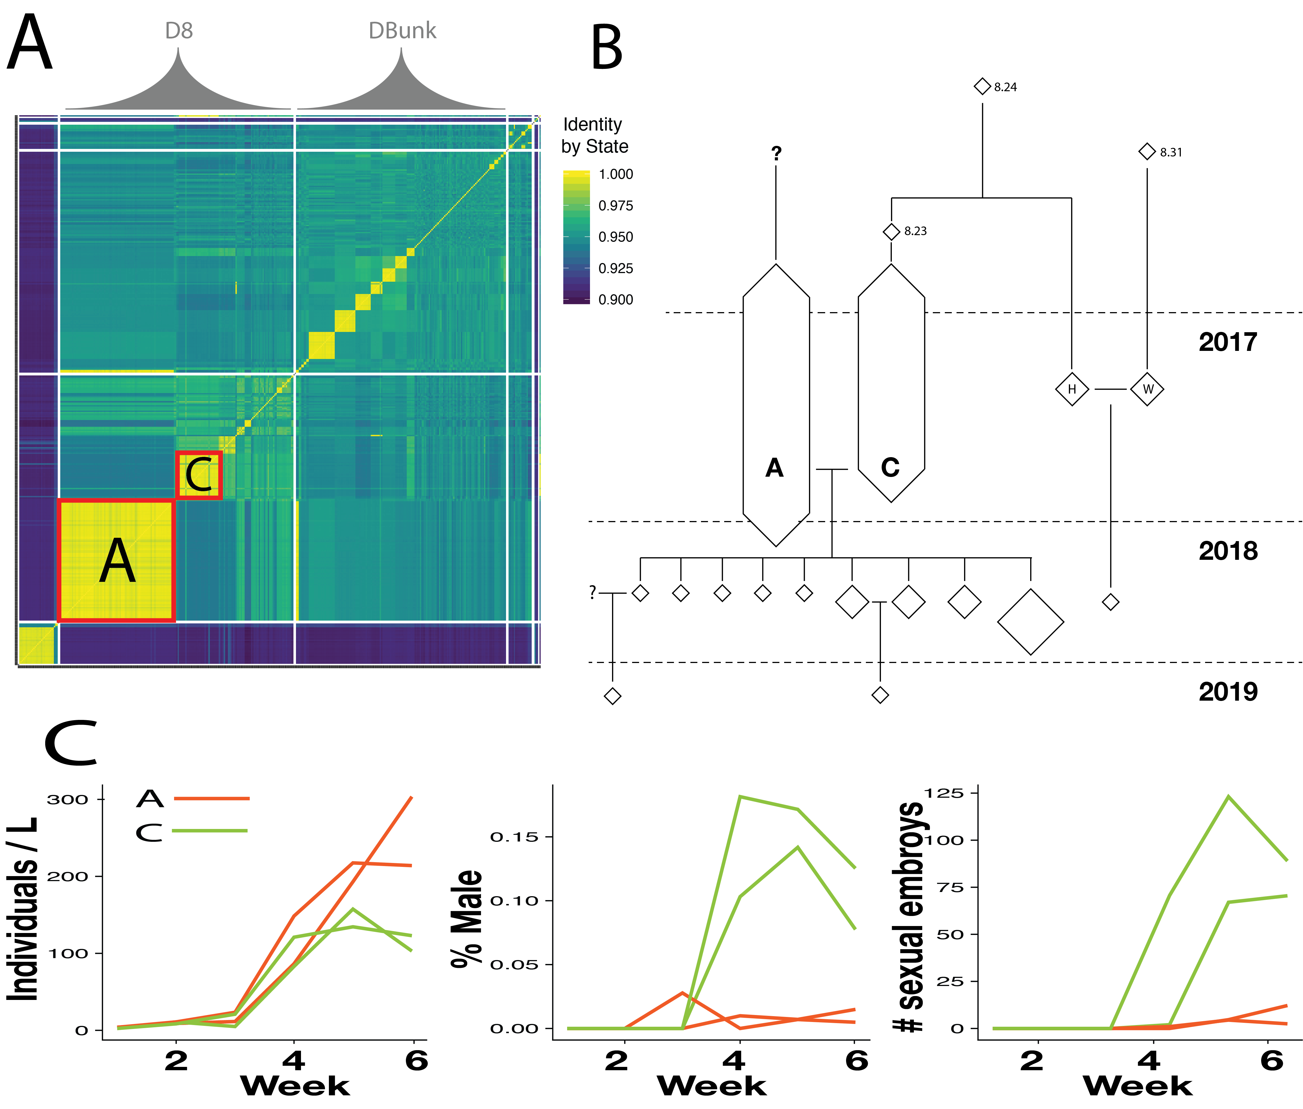

Figure 1. (A) Identity by state matrix for sampled *D. pulex clones*. D8 and DBunk are two intermittently connected ponds which vary in ephemerality. (B) Inferred pedigree (based on K0, K1, Kinship) for D8 clones. (C) Clones A and C are two abundant lineages that vary in reproductive investment

Two dominant clonal isolates sampled from one pond in 2017 exhibit variation in male production rate (~2% vs 15% of total brood over life-time), which leads to a significant difference in population growth rates (*R0*)as measured in lab mesocosms. Polymorphisms in sexual allocation have been observed in other daphnid systems [cite cite cite], but a number of features of the populations we work with differ from previous models, providing us with a unique opportunity to study alternative evolutionary paths of a parallel evolutionary process. Notably, in another system, complete male limitation (i.e., obligate parthenogenesis) arises, recurrently, via introgression from a closely related sister species; male limitation is therefore primarily driven by variation at one-locus, which behaves in a ZW-like fashion [cite]. In the populations that we study, we have identified that variation in male production rate is polygenic, with upwards of ~8 QTL on separate chromosomes segregating between field caught males and females. Neither the dominant lineages, nor these specific QTL, show any evidence of arising via hybridization with another species (although we cannot rule out, at the moment, an unknown ‘ghost’ lineage). Rather, these dominant lineages appear to be cousins, and we hypothesize that alleles contributing to male limitation arise *de novo* within populations.

Because the pond we study periodically goes dry, as it did in the summer of 2018, we have the opportunity to study patterns of segregation in the offspring of these two dominant lineages. Lab based phenotyping of these field derive F1 hybrids, as well as lab reared hybrids and self-crossed lineages, confirms that there is segregating variation for male production within and between the dominant lineages. Ongoing work seeks to narrow the previously identified QTL using these recombinant lineages, and to test for segregation distortion in natural populations. Future work will use these empirical observations of ecology, population dynamics, and genetic architecture to parameterize forward-genetic simulations in which to assess the stability and persistence-time of fitness related genetic variation. This work is important because it examines the forces that generate and maintain variation in a system where variation should be quickly lost due to consanguinity and clonal selection.

Layered on top of the complex evolutionary process caused by intraspecific interactions is a dynamic predatory environment, which fluctuates across time and space. *D. pulex*, like many Cladocera, have plastic responses in a variety of life-history, morphological, and behavioral traits when exposed to predator-derived chemical cues [cite]. One conspicuous morphological response in *D. pulex* is the growth of a defensive helmet and spikes which appear in juveniles in response to predatory phantom midge larvae (*Chaoborus* spp). These dorsal structures increase handling time [cite] thereby reducing mortality [cite], and can be induced in the lab in a dose-dependent manner through the application of reverse-phase extraction of boiled midge larvae [cite]. The extent of this morphological induction varies dramatically between clonal lineages sampled within and between ponds, and has been proposed to be subject to local selection [cite].

We sought to study the genetic basis of variation in predation response and to quantify the extent of mutational variance in phenotypic plasticity. To address these topics, we measured the extent of genetic variation in plasticity among genetically distinct recombinant clones as well as between multiple field isolates of one of the dominant lineages, described above. Note that these clonally related field isolates are not genetically identical, and differ from each other due to mutation and gene conversion [cite]. Indeed, we observe an increase in non-synonymous polymorphism segregating among clonally related field isolates, as expected under mutation accumulation. Plausibly, these mutations could contribute to selective differences among individuals, and could facilitate forms of evolutionary rescue [cite] as *D. pulex* populations get devoured over the course of the growing season [cite].

To conduct this work, we measured morphological induction in ~200 sequenced clones sampled from the Dorset ponds (Becker et al, in prep). In this experiment, we took sequential pictures of the same XYZ individuals for the first three days of development (first two instars). To facilitate an unbiased and reproducible characterization of the developmental plasticity in the dorsal edge, we developed a semi-automated image analysis pipeline, which produces a consistent 700-point trace, along with information about other morphological size characteristics. We find that, as expected, there is more heritable variation in plasticity among the outbred lineages than among the clonally related ones. However, the excess of variation is slight and there is considerable heritable variation in plasticity among clonally related field isolates. The similarity in among genetic variation between outbred and clonaly related individuals is in stark contrast to the orders of magnitude difference observed in laboratory mutation accumulation lines [cite cite cite], and suggests that stabilizing selection is a strong force acting on predatory induced plasticity.

**Overview of Future Research Plans**. The work conducted over the last four years has led to the development of genomic, computational, and experimental resources to study the effects of fluctuating selection on the maintenance of variation. We will build on these advances to directly relate patterns of heritable variation in fitness related traits to the strength of fluctuating selection. This work will take place across a range of environmental conditions, in both lab and field-based settings, and will continue to layer quantitative genetic insight with population genetic inference.

***Drosophila***. Despite ample evidence from phenotypic and genomic analysis (discussed above), the strength extent of seasonal adaptation in *Drosophila* remains only superficially characterized. More generally, and across most taxa, the magnitude and genomic extent of adaptive response to fluctuating selection pressures remains unknown. Technical challenges might limit inference of strength of selection based on population allele frequencies alone (Buffalo and Coop 2020, Lynch et al 2020) and unknown demographic factors many also affect inference of wild populations. Quantitative genetic approaches, on the other hand, may offer an attractive alternative to addressing this fundamental question. To address the strength and magnitude of seasonal selection from quantitative genetic data requires estimating aspects of the genetic architecture of traits, and also measuring the genetic mean of these traits in populations sampled through time. Having these estimates for a large number of traits [cite Houle; more recent] allows one to test hypotheses about the maintenance of genetic variation and whether patterns of genetic variation comport to the standard mutation-selection-balance model or rather, suggest the action of balancing selection. [and what, pray tell, are those?]

To advance our understanding of the strength of selection and the magnitude of adaptive response to seasonally fluctuating environments, we will perform overwintering truncation selection experiments [cite]. The basic logic of this experiment is as follows: Using a Hybrid Swarm design, derived from inbred lines collected along the East Coast, we can accurately estimate heritability (*h2*) of a trait using a genetic relationship matrix (cite) estimated from genome-reconstructions (described above). If we measure the mean phenotype of the population in the generation before and the generation(s) after a selective event, we can estimate the response to selection (*R*). Using the breeder’s equation [cite], or its multivariate equivalent [cite], we can subsequently estimate the strength of selection (*S*). We can apply this technique to study the strength of selection across the transcriptome to obtain a more generalized, and unbiased understanding of the distribution of selection and the magnitude of adaptive response to short term fluctuations in selection pressure [r/w]. By conducting these truncation selection experiments in the lab (e.g., in response to freezing; Stone et al 2020) and in the field (e.g., over winter in outdoor mesocosms), we can validate that seasonally varying selection is, indeed, operating in these populations and gain insight into the adaptive responses to specific selective events. This approach could either examine gene-expression taken across a single whole animal, or a specific tissue type (e.g., the head). We have successfully extracted RNA- and DNA- from single individuals (Weller et al, in prep), and it is even likely that we can reconstruct accurate genomes via RNA seq data alone. Low-cost RNA-seq libraries will be made using BRB-seq [cite]. Note, that because the goal of these experiments is to measure components of variation we will only require, maximally, on the order of 1000-2000 individuals phenotyped and genotyped, as estimation of heritabilities based on GRM approaches are accurate with a limited number of individuals [cite]. Although detecting eQTL is not the main purpose of these experiments, regions of the genome associated with heritable variation in gene expression can be identified using mixed effect modeling [cite] or sparse linear models [cite]. This work will identify putative phenotypic targets of natural selection, and will elucidate aspects of the physiological and developmental basis of local adaptation.

***Daphnia***. Future work in Daphnia will examine the evolutionary outcomes of temporal variation in selection pressure. The goal of this work is to examine how seasonal cycles of clonal growth and sex lead to the evolution of polymorphism and to the evolution of plasticity / bet-hedging. By addressing these topics in Daphnia, we can test basic predictions [cite cite cite] about the relationship between the predictability of environmental change on the evolution of these components of phenotypic variance.

First, we will continue our work studying the evolution of polymorphism in sexual investment. We will approach this work using both laboratory experiments and observational studies of natural populations. To experimentally test the evolutionary dynamics of sexual investment, we will conduct crosses within and between clonal lineages and compete these recombinant offspring in mesocosms. We will focus on the two clonal lineages that we have studied extensively which show polymorphism in male production rate (A and C, Figure X), although we will also generalize this work by expanding analysis to other clones from the Dorset area, or elsewhere, when appropriate. Competition experiments will be seeded with ephippia derived from selfing and outcrossing of these parental clones, and we will track the frequency of recombinant clones through time using a combination of pooled and individual sequencing. These estimates of frequency directly relate to fitness. Note that sequencing effort for this type of experiment can be kept at a reasonable level because we have (or can easily generate) phased genomes for parental clones via trio-phasing [cite]. Contrasting of the fitness of selfed vs. outcrossed offspring will allow us to assess the consequences of inbreeding depression and determine whether fitness is affected by any over-dominant alleles [cite] which could arise via true overdominance or associative overdominance [cite]. We will couple these experimental approaches with continued sampling and analysis of population genomic data from the Dorset populations. We will work to examine patterns of molecular evolution as they relate to the inferred pedigree and test whether loci involved in male limitation appear to arisen recently in these populations (via mutation or migration) or whether they have persisted in these populations for long periods of time. This analysis will take advantage of recent advances in ancestral recombination graph (ARG) analysis [cite cite cite] and will couple the analysis of phased genome data with extensive forward simulation [cite], parameterized by known ecological aspects of these ponds.

The second major Daphnia project that we will pursue examines apparent bet-hedging in the requirement of vernalization for ephippial hatching. Examination of hatching patterns in lab generated crosses shows that ~30% of ephippia spontaneously hatch without any vernalization cue; the remainder require a combination of cold temperatures and dark, followed by exposure to light and warmth to hatch. In other Daphnia populations, vernalization is required for any hatching [cite cite cite], and the appearance of spontaneous hatching likely reflects the ecology of the ponds that we are studying. Notably, the ponds that we study dry periodically and likely stochastically from year to year, plausibly leading to the evolution of bet-hedging [cite]. Preliminary analysis suggests that variation in vernalization requirements is not genetic – siblings within the same ephippial case tend to hatch simultaneously – suggesting maternally deposited cues determine the timing of hatching. To advance our understanding of the biology of vernalization, we will first assess genetic variation in spontaneous hatching among clones and between ponds that vary in ephemerality. We will follow up this work by identifying the genetic basis of variation via bulk segregant analysis of F1 crosses between clones that show variation in vernalization requirement. We will use bisulfite sequencing of freshly deposited embryos in order to determine whether maternal modification of methylation state is correlated with the rate of spontaneous hatching.

**Conclusion**.